Anantha Lakshmi Institute of Technology and Sciences (ALITS)
Department of Data Science

Visualizing Housing Market Trends: An Analysis of Sale Prices and Features using Tableau
Project Design Phase — Solution Architecture

Project Name: Housing Market Trends using Tableau
Team ID: ALITS-DS-2026-HousingMarketTrends
Academic Year: 2026

Solution Architecture
This document describes the end-to-end architecture of the Housing Market Trends using Tableau solution, from raw data ingestion to the published, interactive dashboard actually built for this project.
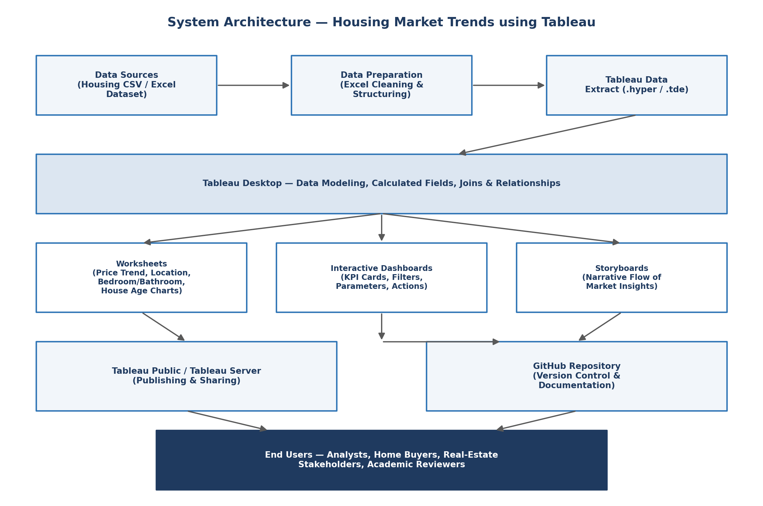
Figure 3.2: System Architecture Diagram
Architecture Layers
Layer | Description | Tool Used
Data Source Layer | Transformed_Housing_Data_2.csv — 21,609 records, 30 engineered fields | Microsoft Excel
Data Modeling Layer | Connecting the CSV in Tableau and defining Measure Names/Values for KPI cards | Tableau Desktop
Analysis & Visualization Layer | Sheet 1 (KPIs), Sheet 2 (histogram), Sheet 3 (pie), Sheet 4 (bar chart) | Tableau Desktop
Presentation Layer | Dashboard 1 (Comprehensive House Price Analysis) and Story 1 (5-point storyboard) | Tableau Desktop
Publishing Layer | Hosting the workbook for public/stakeholder access | Tableau Public
Documentation Layer | Project documentation and version history | GitHub

Actual Worksheet Design (as built)
Worksheet | Chart Type | Key Fields
Sheet 1 | KPI Text Table | CNT(Transformed Housing Data), SUM(Sale Price), SUM(Area of the House from Basement)
Sheet 2 — Total Sales by Years Since Renovation | Histogram | Sale Price (bin) on Columns, CNT(Sale Price) on Rows
Sheet 3 — Distribution of House Age by Renovation Status | Pie Chart | Age of House (in Years) as Angle/Color, SUM(Ever Renovated Yes)
Sheet 4 — House Age Distribution by Bathrooms, Bedrooms & Floors | Grouped Bar Chart | Age of House (in Years) & Measure Names on Columns, Measure Values on Rows
Dashboard 1 — Comprehensive House Price Analysis | Combined Dashboard | Sheets 1–4 combined with shared Age of House filter
Story 1 | 5-point Storyboard | Comprehensive House Price → Dashboard Highlights → Sales Distribution → Age varies → House age distribution

Dashboard Screenshots (Actual Build)
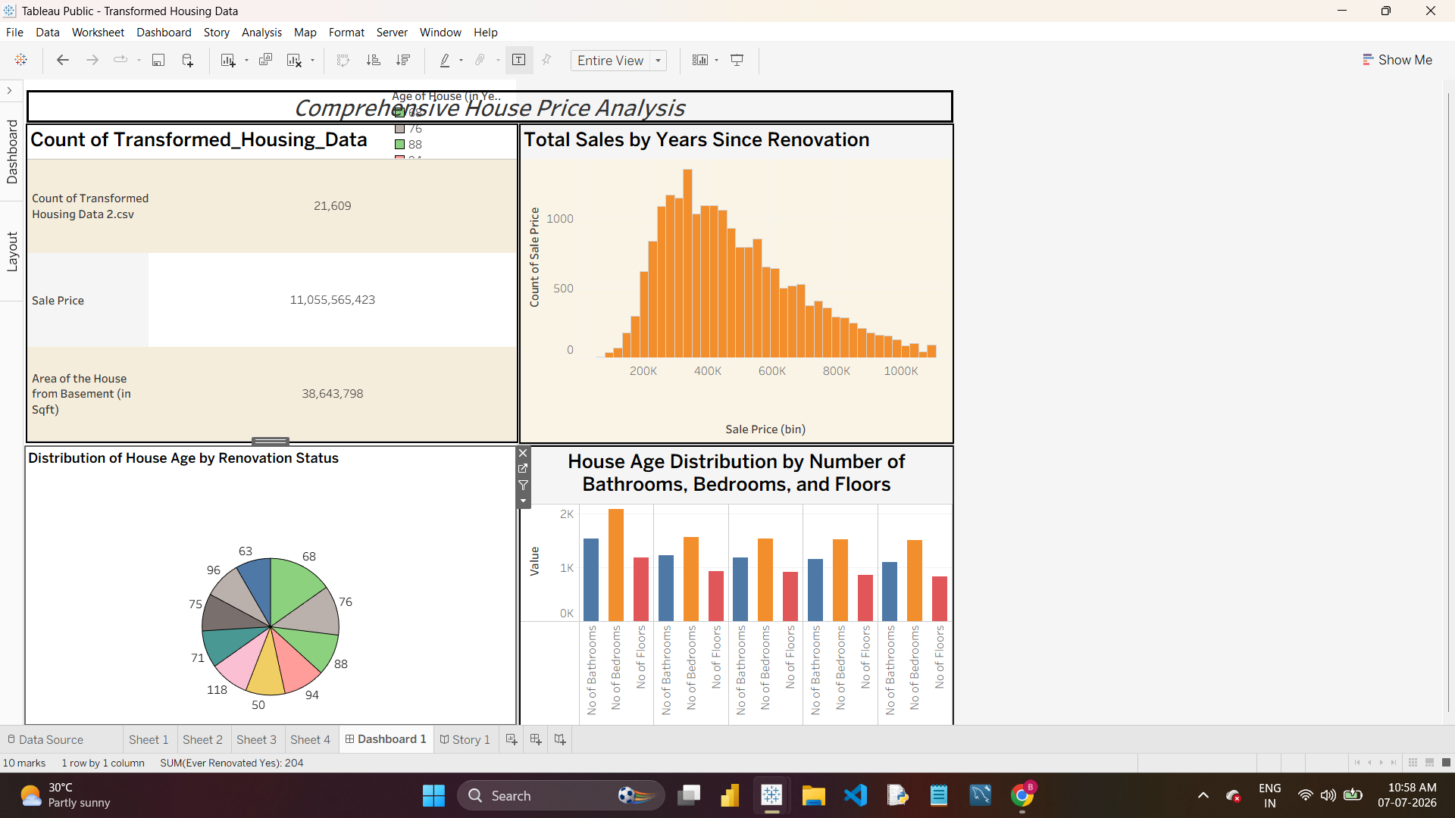
Figure 3.3: Dashboard 1 — Comprehensive House Price Analysis
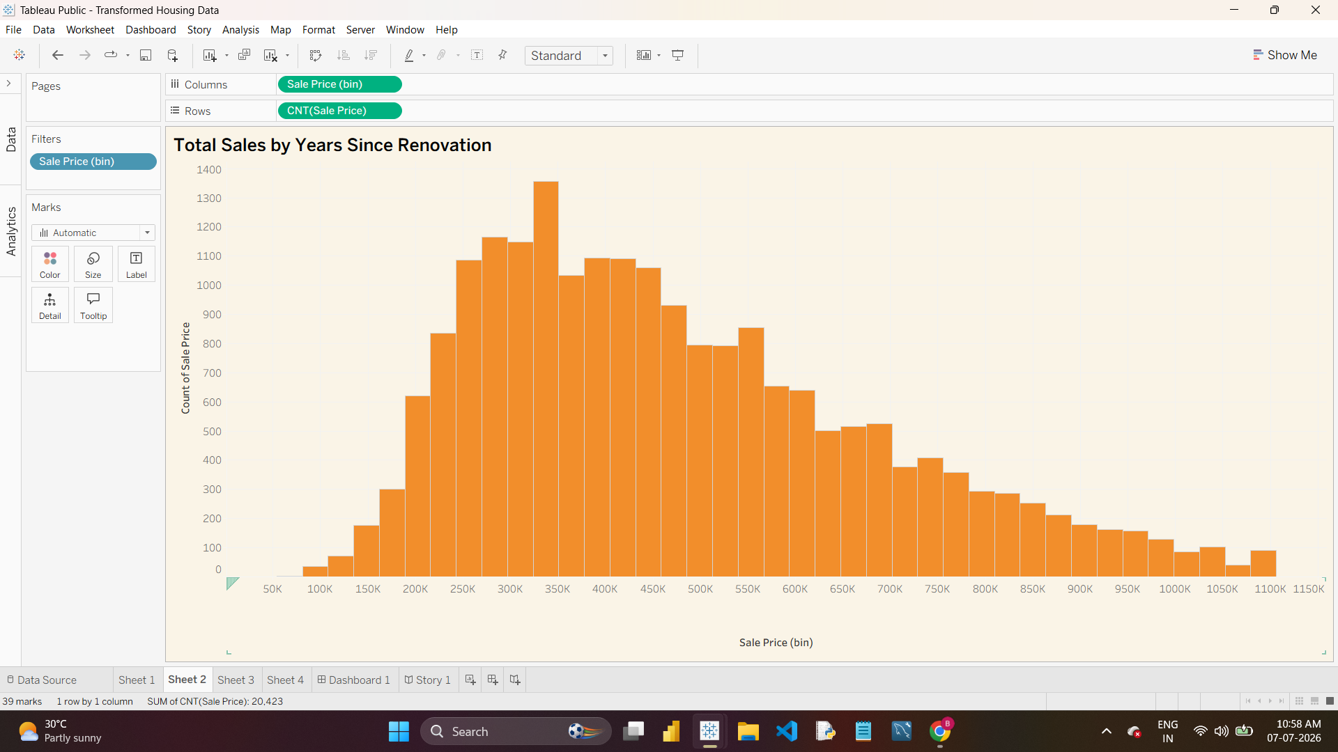
Figure 3.4: Sheet 2 — Total Sales by Years Since Renovation (Sale Price Histogram)
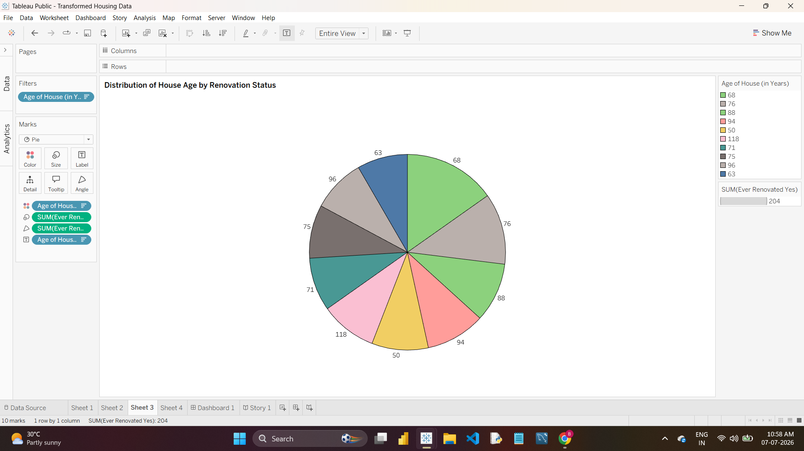
Figure 3.5: Sheet 3 — Distribution of House Age by Renovation Status
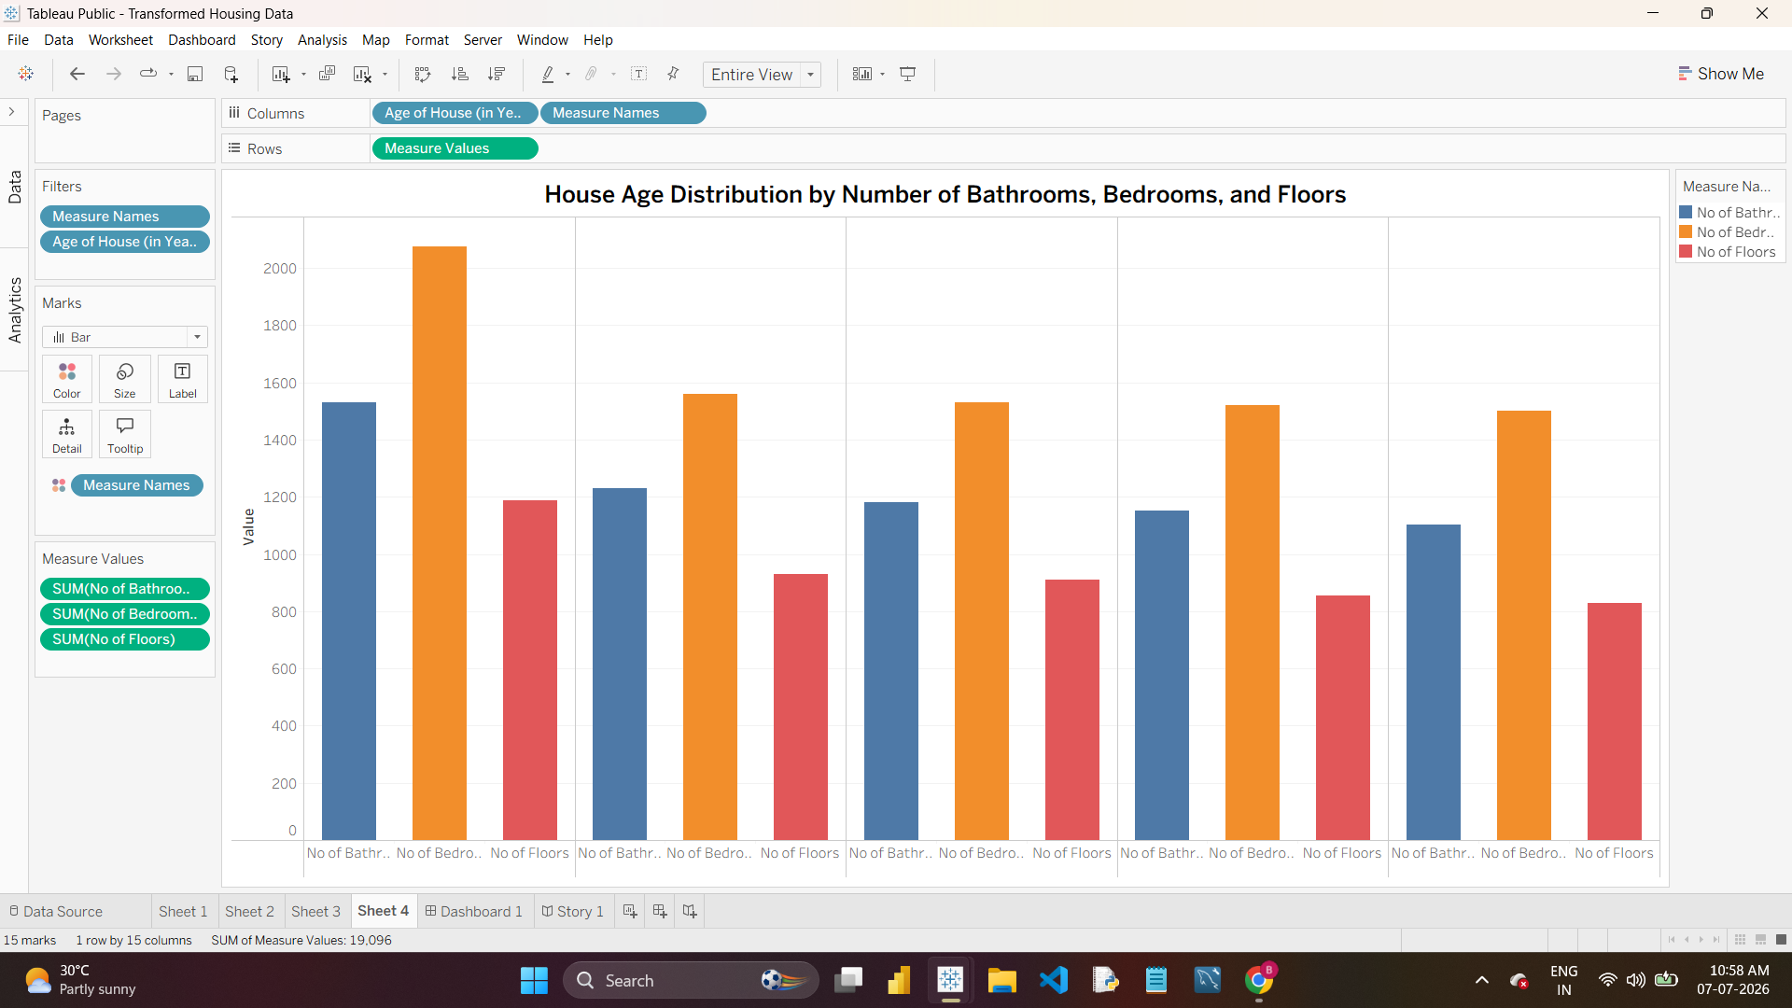
Figure 3.6: Sheet 4 — House Age Distribution by Bathrooms, Bedrooms and Floors
Component Diagram
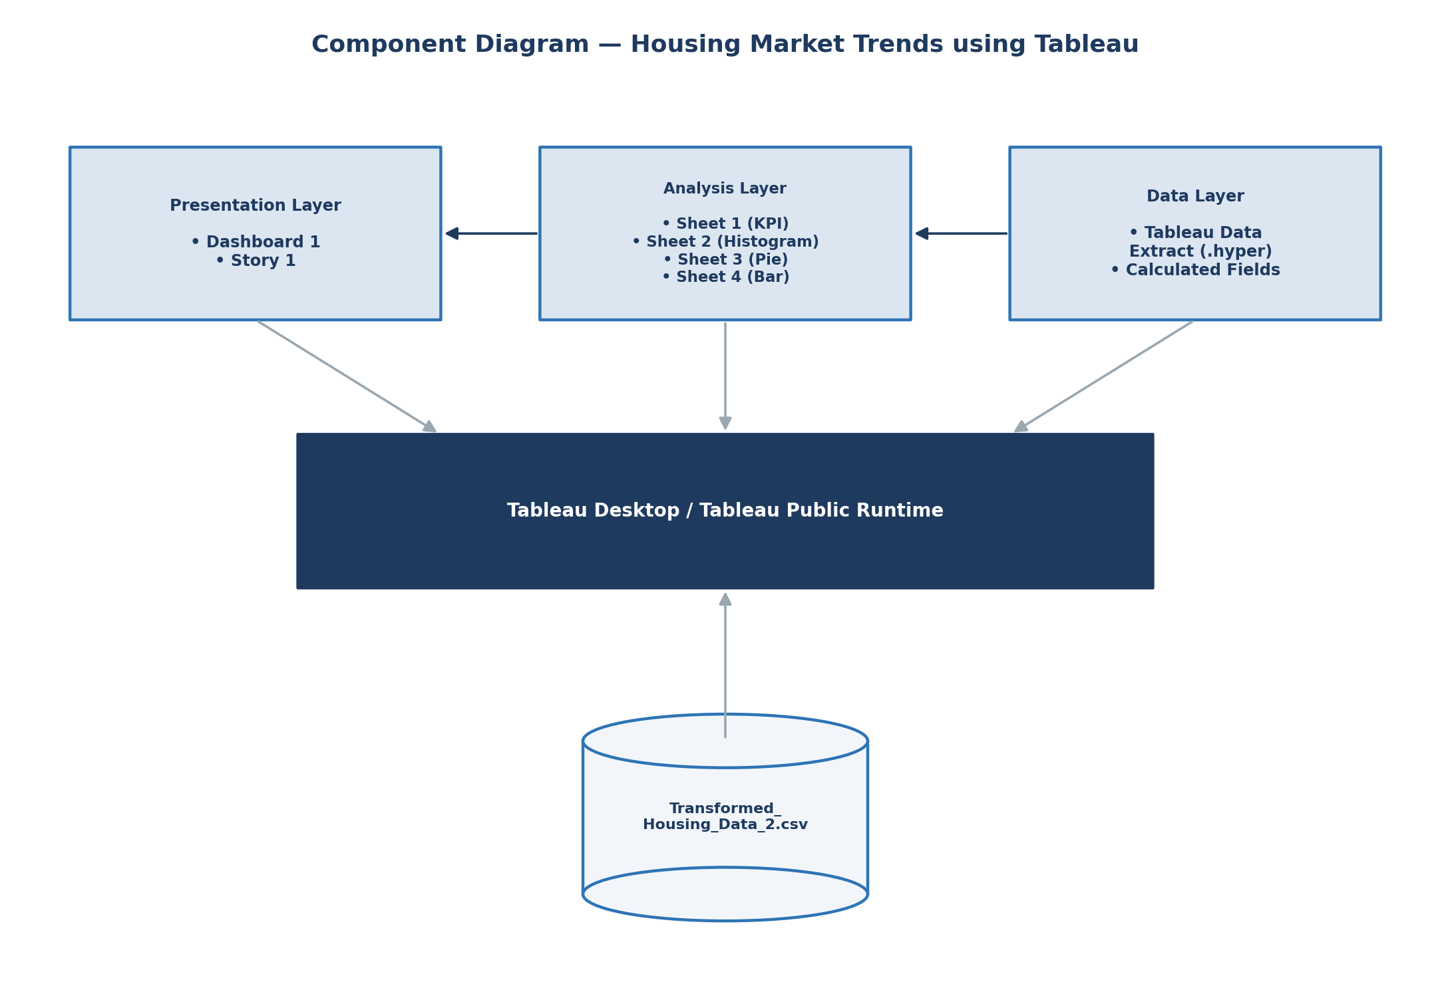
Figure 3.7: Component Diagram — Presentation, Analysis, and Data Layers
The component diagram groups the solution into three layers running inside the Tableau Desktop / Tableau Public runtime: the Presentation Layer (Dashboard 1, Story 1), the Analysis Layer (Sheet 1–4), and the Data Layer (the Tableau data extract and calculated fields built on Transformed_Housing_Data_2.csv).
Use Case & Flow Diagrams
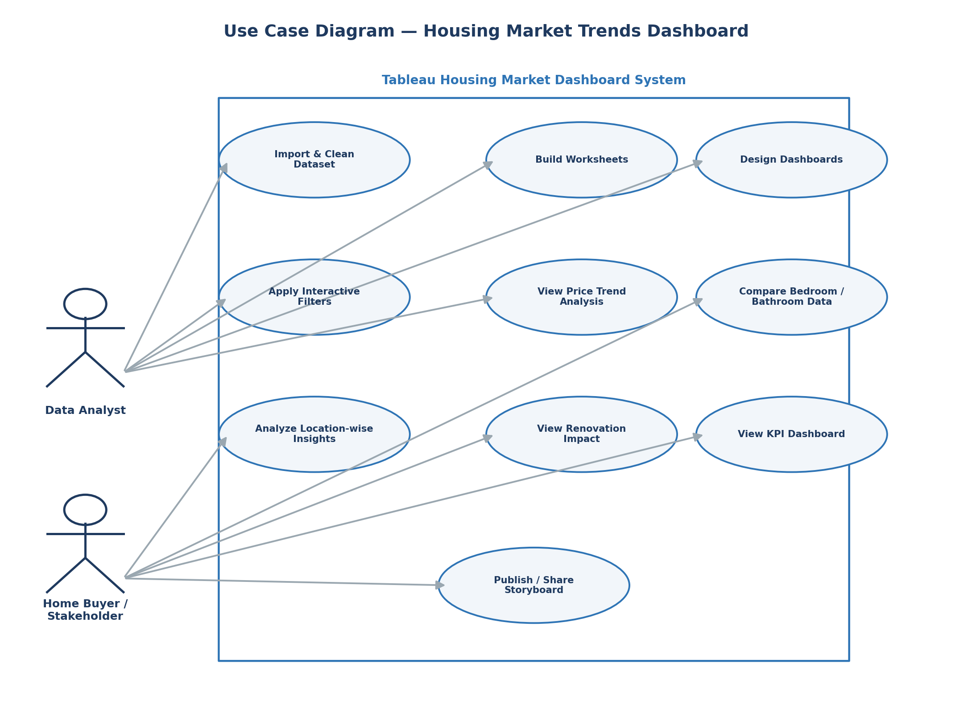
Figure 3.8: Use Case Diagram
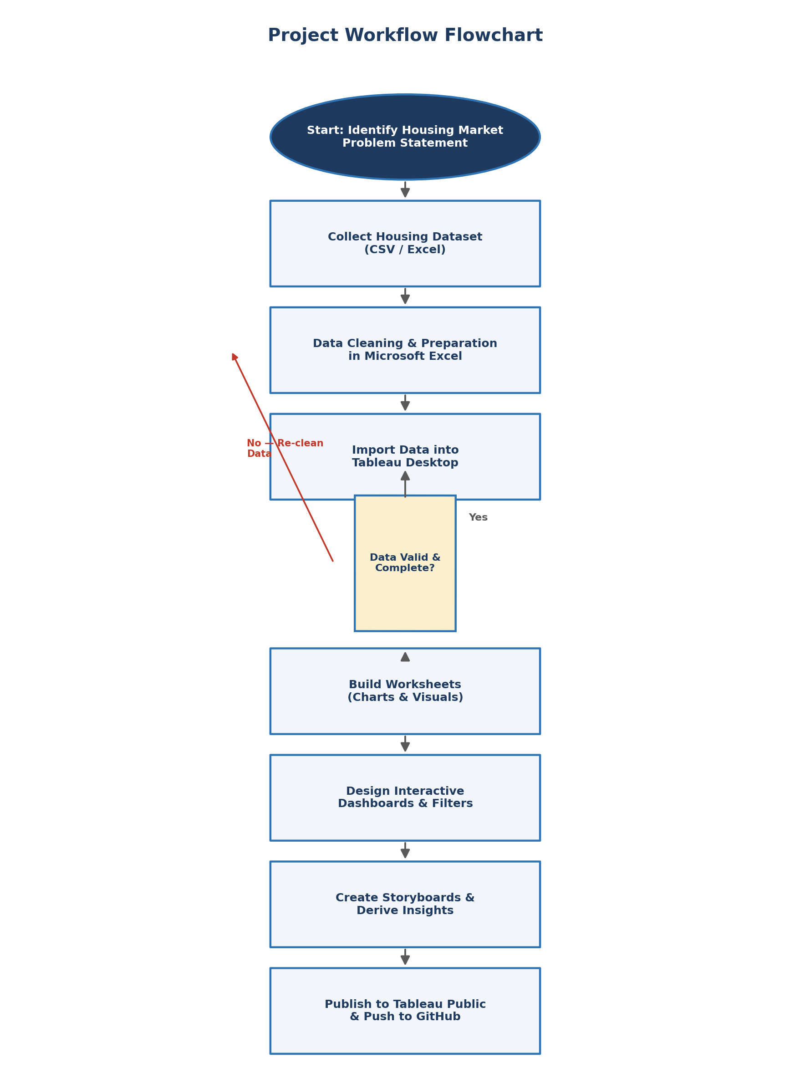
Figure 3.9: Project Workflow Flowchart

